Day 9

Class Exercise 3

@PostMapping("/api/village")

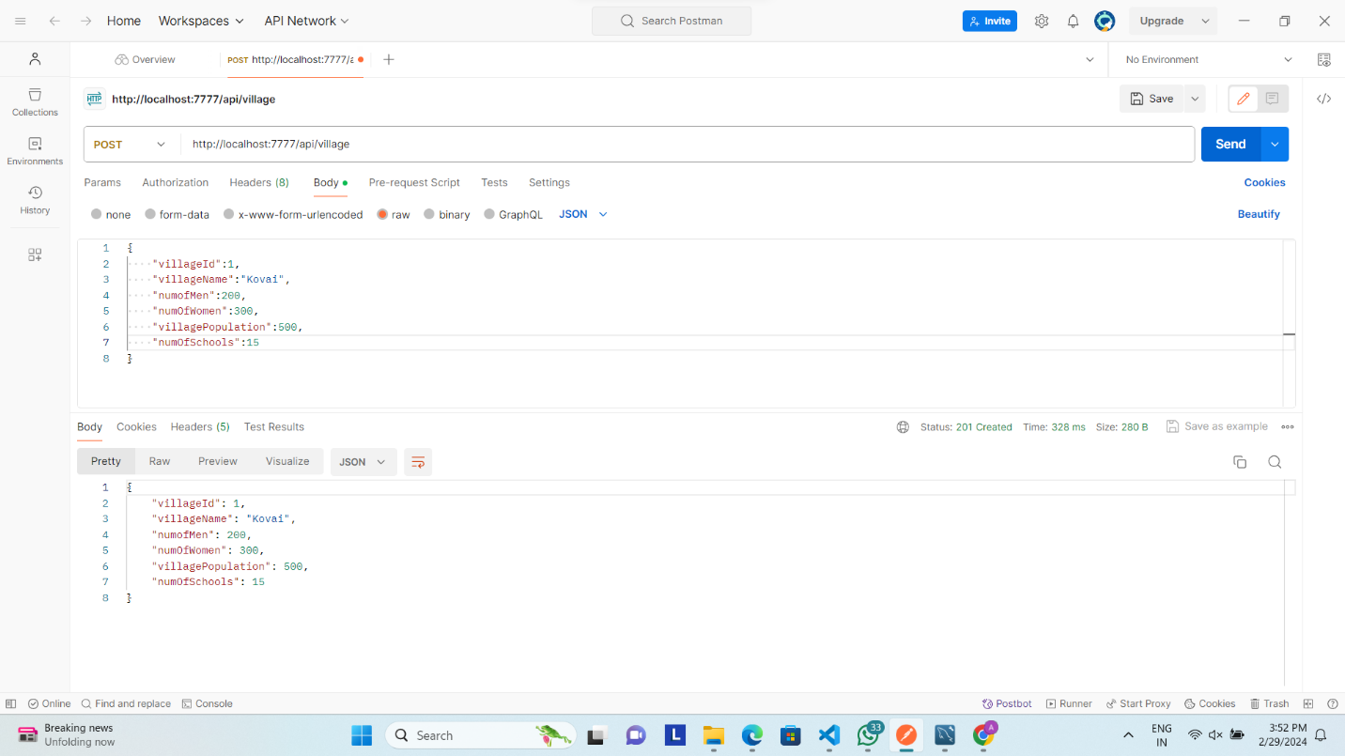

@GetMapping("/api/village/byname/{villageName}")

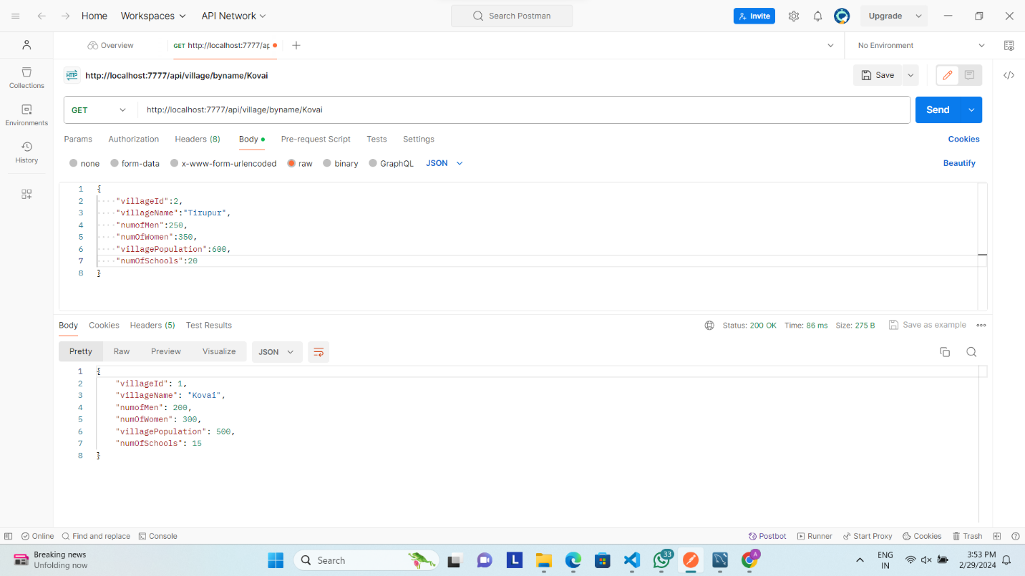

@GetMapping("/api/village/bypopulation/{villagePopulation}")

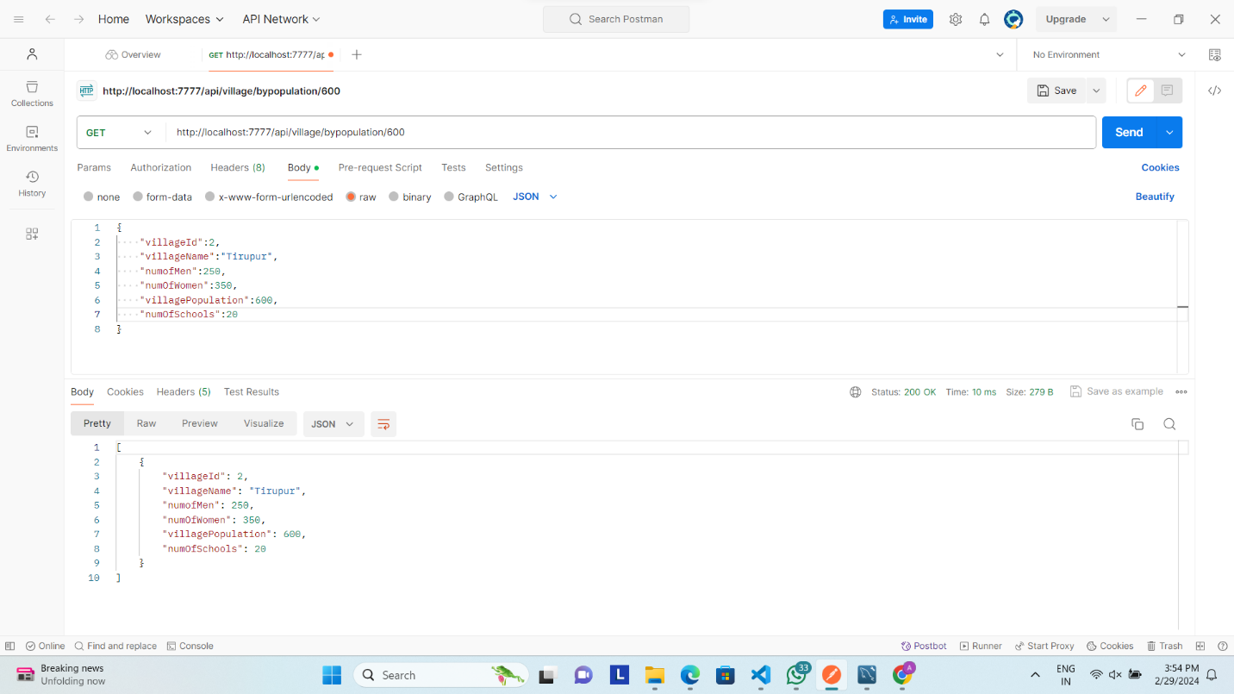

@GetMapping("/api/village/{villageId}")

